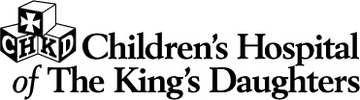
601 Children’s Lane . Norfolk, VA 23507

Securities Transfer Information
(Updated November 2015)

Thank you for considering a gift to CHKD. Gifts of securities are transferred into our account without any identifying donor information.
Please let us know:

- Type of security
- Number of shares
- Firm that is transferring the security to CHKD
- Name of donor

Please provide the following information to your Financial Advisor transferring your gift of securities to CHKD:

Firm: Morgan Stanley

Broker : Ed Hipp 757-493-2105

Asst: Jennifer Cornforth 757-493-2110
Jennifer.A.Cornforth@morganstanley.com

DTC: 0015

Account#: 529106912 CHKD

CHKD Staff handling stock transfers: Dawn Sain 757-668-9362

Please contact us if you have any questions. gifts@chkd.org or 757-668-7070.

